Employee Class –

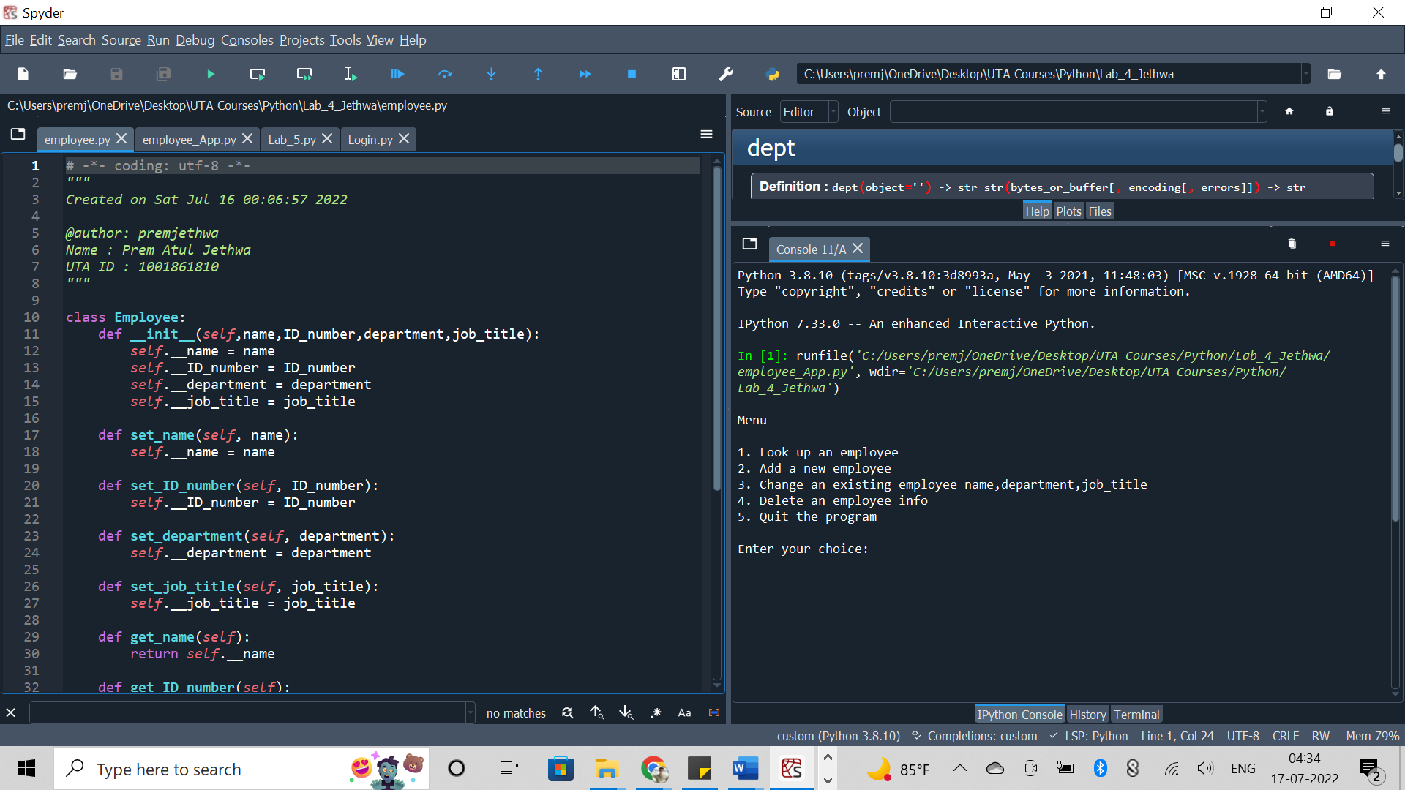

employee_App –

Add a new employee to the dictionary

Look up an employee in the dictionary

Change an existing employee’s name, depart, and job title in the dictionary

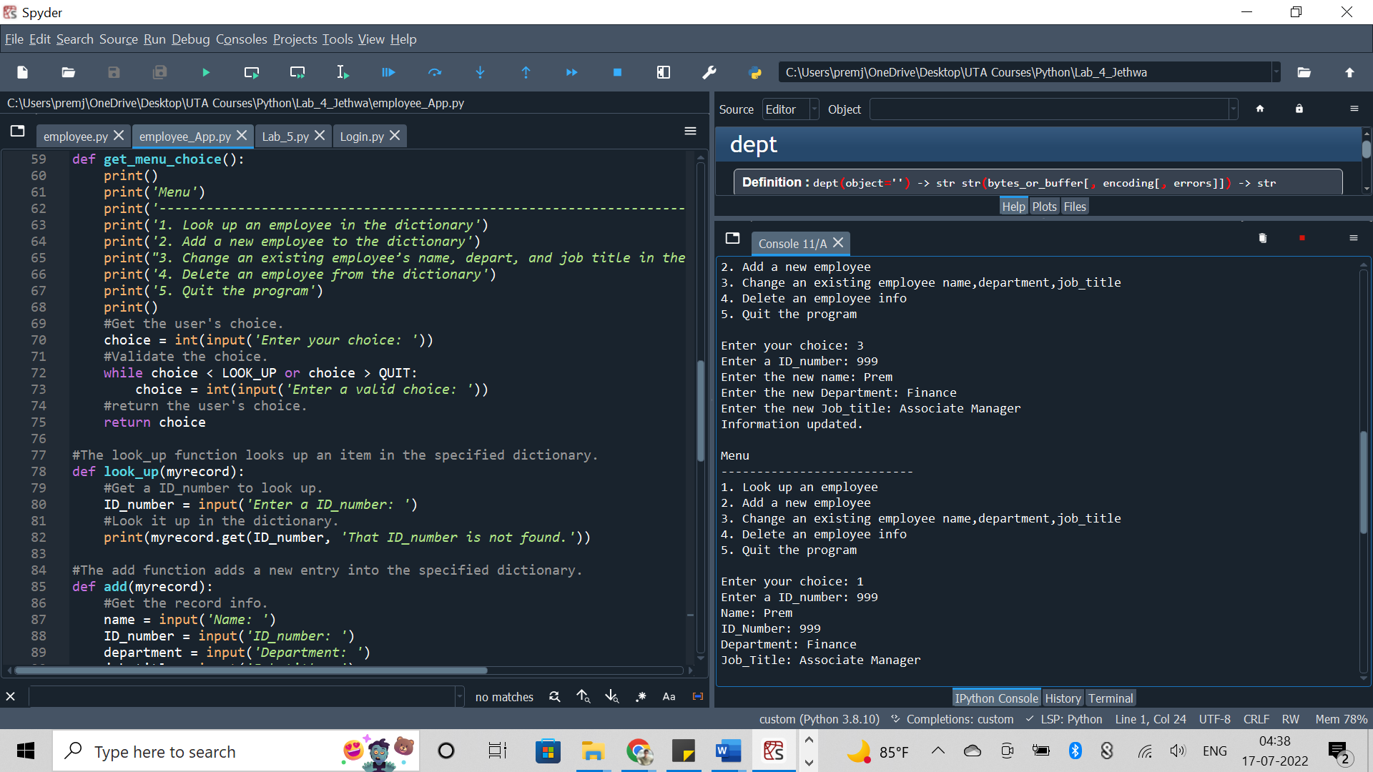

Delete an employee from the dictionary

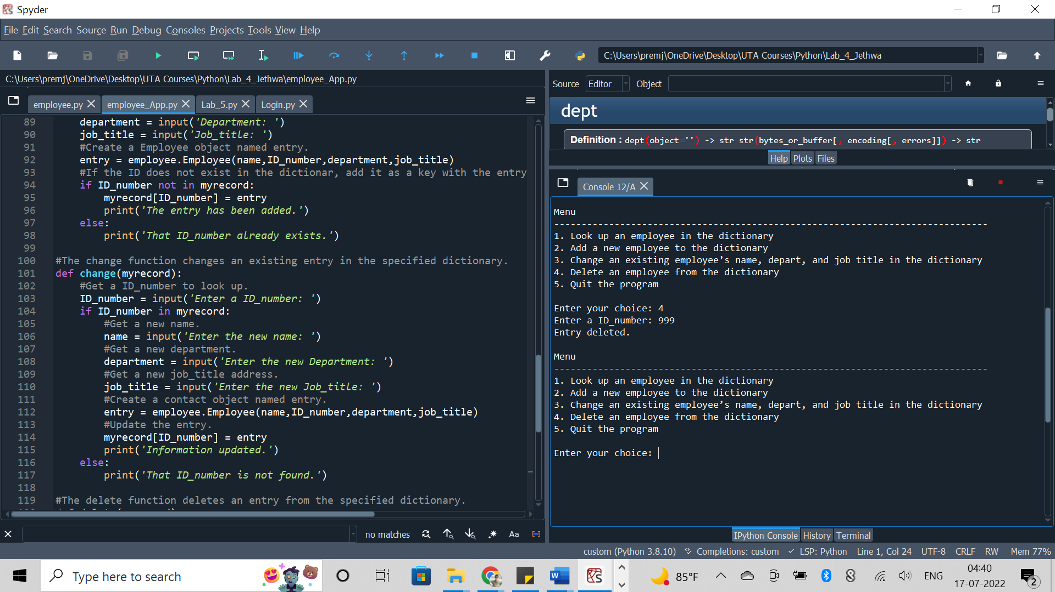

Quit the program

